***Assignment-5***

|  |  |
| --- | --- |
| **Project Domain** | Cloud Application Development |
| **Project Title** | News Tracker Application |
| **Team ID** | PNT2022TMID40746 |
| **Name** | JEEVA S |
| **Roll No** | 61101904009 |
| **Date** | 17th Oct 2022 |

# Questions:

1. Create a Bucket in IBM object storage.
2. Upload 5 images to IBM object storage and make it public. write html code to displaying all the 5 images.
3. Upload a CSS page to the object storage and use the same page in your HTML code.
4. Design a chatbot using IBM Watson assistant for hospital. Ex: User comes with query to know the branches for that hospital in your city. Submit the web URL of that chat bot as an assignment.
5. Create Watson assistant service with 10 steps and use 3 conditions in it. Load that script in HTML page

# ------------------------------------------------------------------------------------------------

# Answers:

*1.Create a Bucket in IBM object storage.*

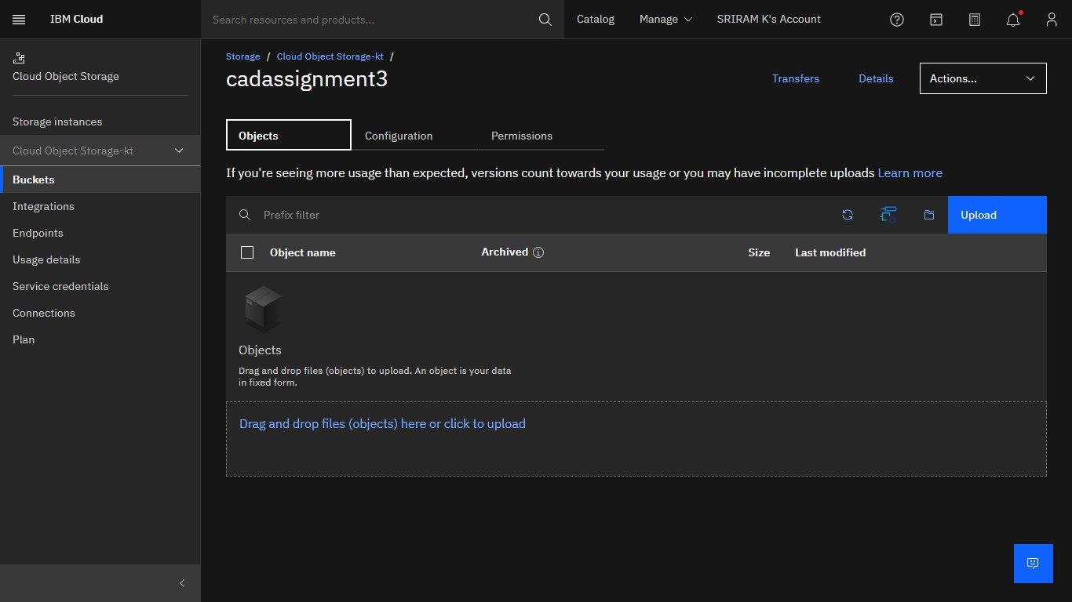

# ------------------------------------------------------------------------------------------------

*2. Upload 5 images to IBM object storage and make it public. write html code to displaying all the 5 images.*

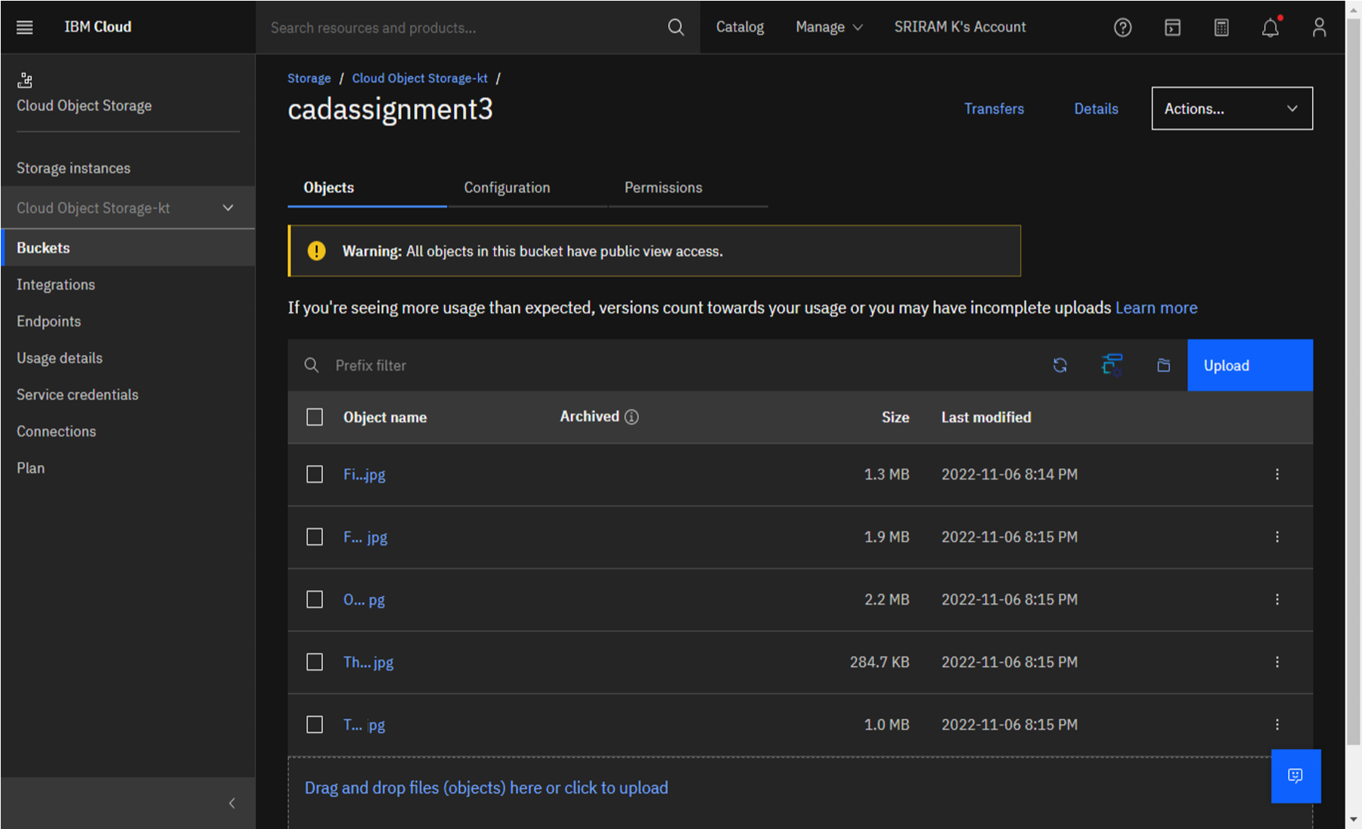

# ------------------------------------------------------------------------------------------------

*3.Upload a CSS page to the object storage and use the same page in your HTML code.*

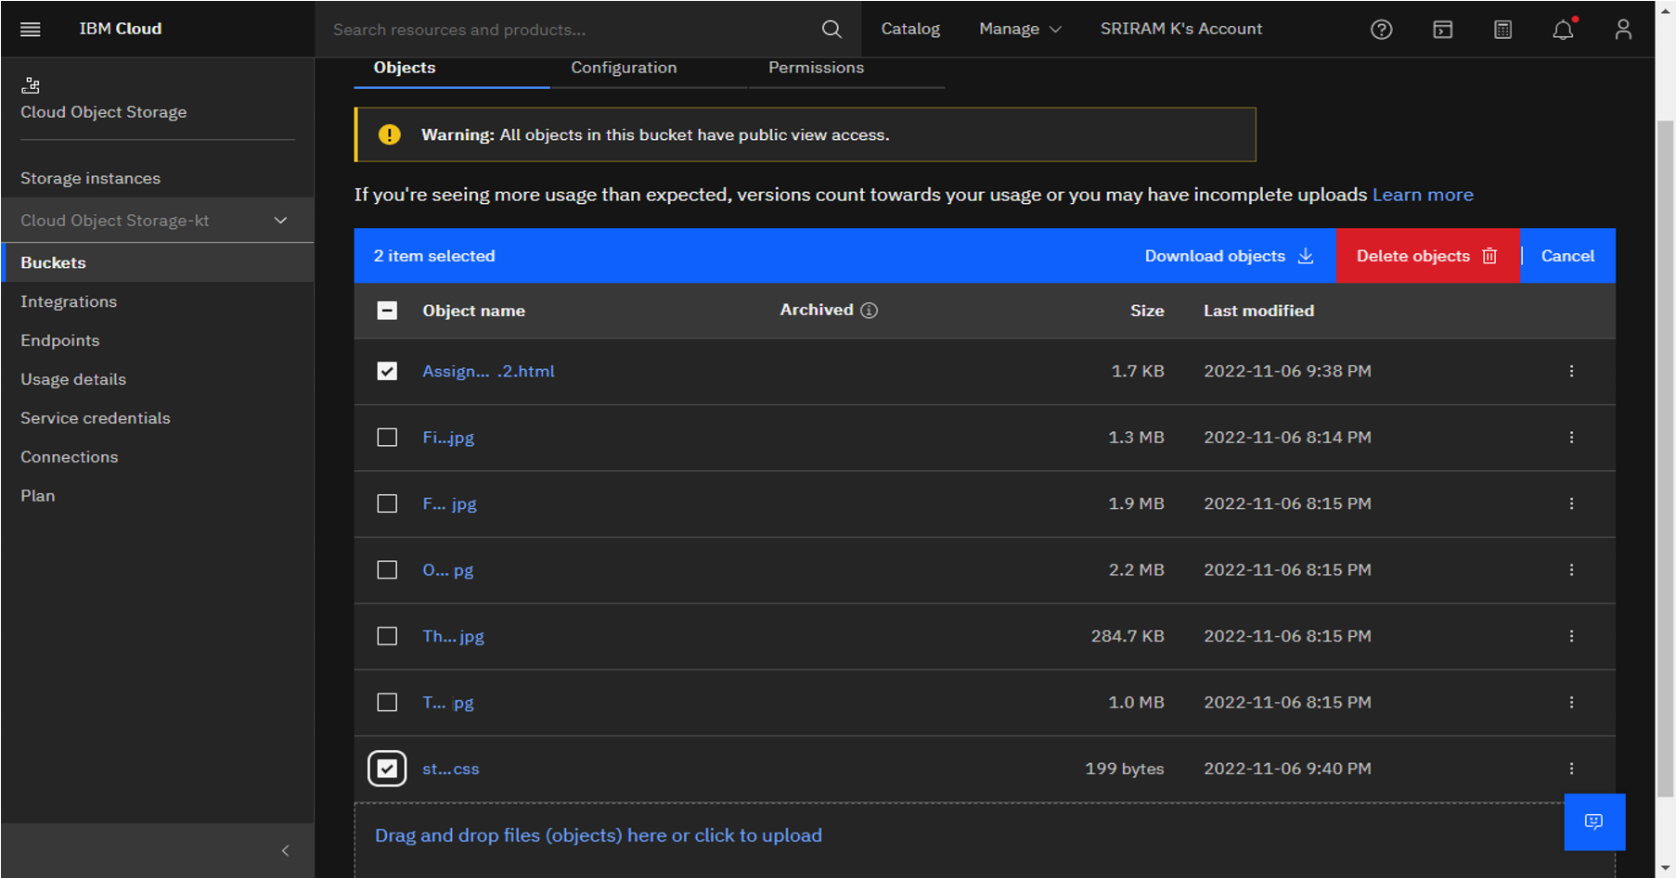

# ------------------------------------------------------------------------------------------------

*4. Design a chatbot using IBM Watson assistant for hospital. Ex: User comes with query to know the branches for that hospital in your city. Submit the web URL of that chat bot as an assignment.*

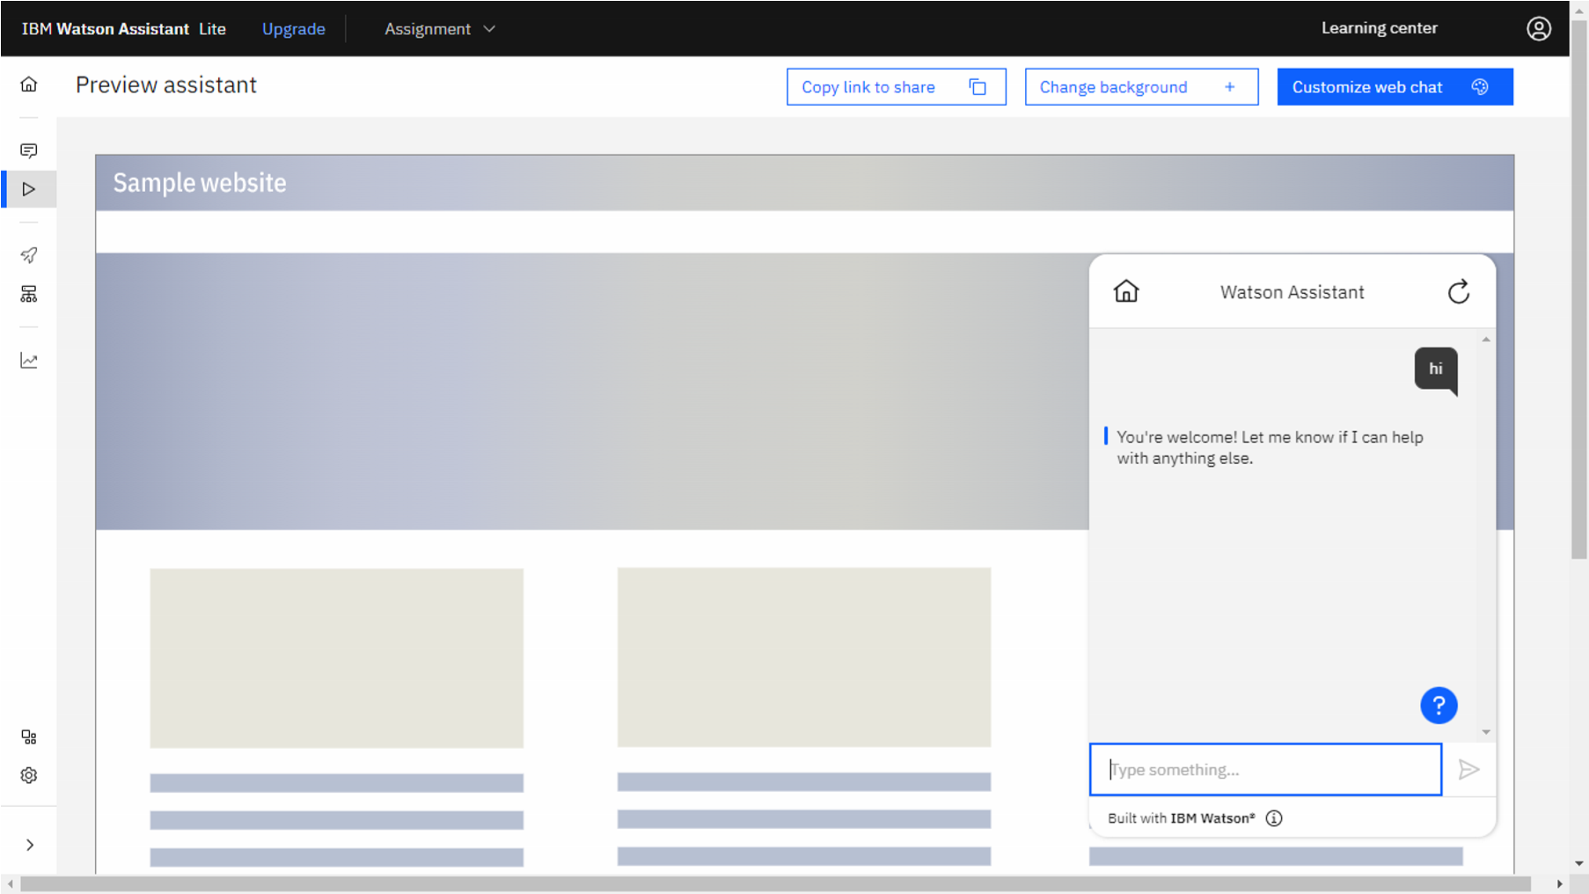

# ------------------------------------------------------------------------------------------------

5.Create Watson assistant service with 10 steps and use 3 conditions in it. Load that script in

HTML page

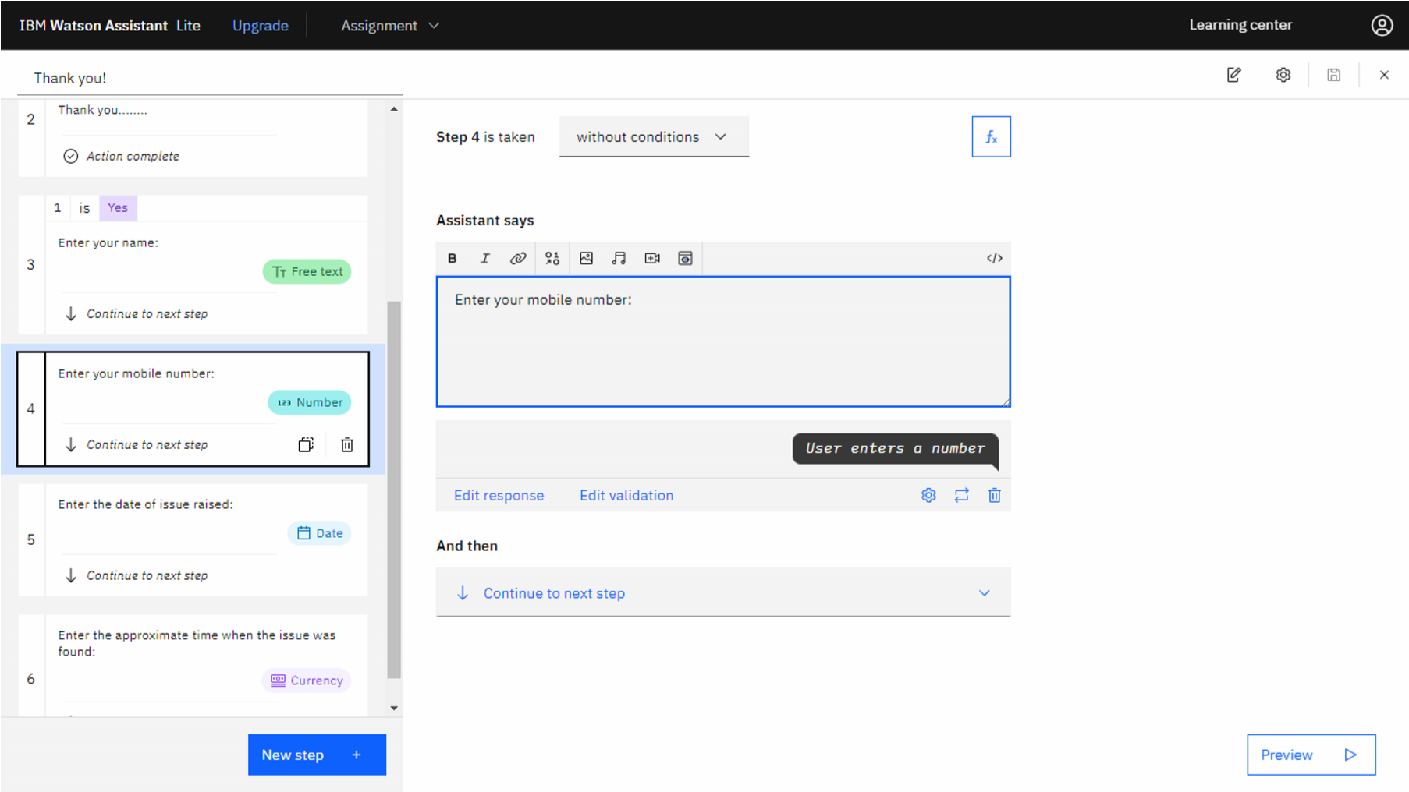

# ------------------------------------------------------------------------------------------------

|  |
| --- |
| ***Assignment-3.2.html:***    <html>  <head>  <title>Images From IBM-Cloud Object Storage</title>  <link rel="stylesheet" type="text/css" href="style.css">  <script>  window.watsonAssistantChatOptions = { integrationID: "b0a66923-ff2e-46ec-93ec-259b020197b5", // The ID of this integration. region: "au-syd", // The region your integration is hosted in. serviceInstanceID: "a57bbab3-1d2e-4714-ae9b-c3c2c507ef41", // The ID of your service instance. onLoad: function(instance) { instance.render(); }  };  setTimeout(function(){  const t=document.createElement('script');  t.src="https://web-chat.global.assistant.watson.appdomain.cloud/versions/" +  (window.watsonAssistantChatOptions.clientVersion || 'latest') +  "/WatsonAssistantChatEntry.js";  document.head.appendChild(t);  });  </script>  </head>  <body>  <center>    <h1>Image-1 From IBM-Cloud Object Storage</h1>  <img height="400" width="500" src="https://cadassignment3.s3.jptok.cloud-object-storage.appdomain.cloud/One.jpg"></br></br>    <h1>Image-2 From IBM-Cloud Object Storage</h1>  <img height="400" width="500" src="https://cadassignment3.s3.jptok.cloud-object-storage.appdomain.cloud/Two.jpg"></br></br>    <h1>Image-3 From IBM-Cloud Object Storage</h1>  <img height="400" width="500" src="https://cadassignment3.s3.jptok.cloud-object-storage.appdomain.cloud/Three.jpg"></br></br>    <h1>Image-4 From IBM-Cloud Object Storage</h1>  <img height="400" width="500" src="https://cadassignment3.s3.jptok.cloud-object-storage.appdomain.cloud/Four.jpg"></br></br>    <h1>Image-5 From IBM-Cloud Object Storage</h1>  <img height="400" width="500" src="https://cadassignment3.s3.jptok.cloud-object-storage.appdomain.cloud/Five.jpg">    </center>  </body>  </html> |
| ***style.css:***    body{  background-color:orange;  text-align: center;  }  h1{  font-style: italic; size: 30px;  } p{  font-size: 20px;  }    .blue{ color: blue;  } .red{ color: red; } .green{ color: green;  } |
| Link: [*https://cadassignment3.s3.jp-tok.cloud-object-storage.appdomain.cloud/Assignment3.2.html*](https://cadassignment3.s3.jp-tok.cloud-object-storage.appdomain.cloud/Assignment-3.2.html) |

